**Module 4 Critical Thinking: Option 1**

Andrew Barnes

Colorado State University Global

CSC320-1

Dr. Schwartz

9/10/2023

**Pseudo Code**

1. Set the scanner to read user input
2. Initialize total = 0
3. Declare average, maximum as null, and minimum as null
4. Set count = 0
5. While count < 5
   1. Print “Enter value ” + (count + 1) + “: “
   2. Try
      1. Read user input as double
      2. Add user input value to the total
      3. If maximum = null or user input value > maximum
         1. Set user input as the maximum
      4. If minimum = null or user input value < minimum
         1. Set user input as minimum
      5. Add 1 to the count
   3. Catch the input mismatch exception
      1. Print “Invalid input. Please enter floating-point number.”
      2. Consume the invalid input
6. Close the activated scanner
7. Calculate the average by dividing the total by 5
8. Calculate 20% interest on the total by multiplying the total by 0.20
9. Print the resulting total, average, maximum, minimum, and interest

**Source Code**

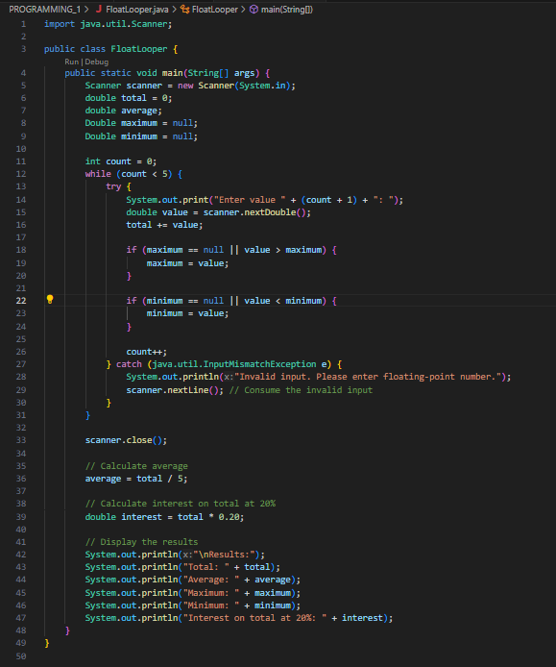

**Executing the Application**

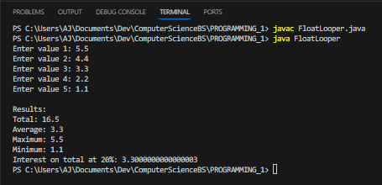

**Git Repository**

**Git Status**

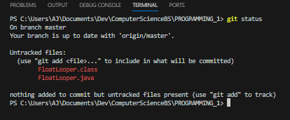

**Git Add**

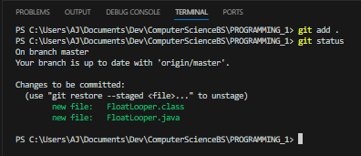

**Git Commit**

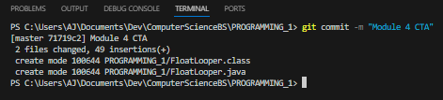

**Git Push**

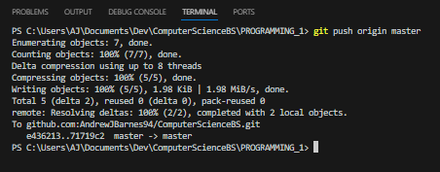

**GitHub Repository**

[**ComputerScienceBS/PROGRAMMING_1/FloatLooper.java at master · AndrewJBarnes94/ComputerScienceBS (github.com)**](https://github.com/AndrewJBarnes94/ComputerScienceBS/blob/master/PROGRAMMING_1/FloatLooper.java)